**JAVA TEST EXAM ON 24-07-2024(WEDNESDAY)**

**CSA0961**

**1.** **import java.util.HashMap;**

**class StudentAttendanceSystem {**

**HashMap<Integer, HashMap<String, Boolean>> attendanceRecords;**

**public StudentAttendanceSystem() {**

**attendanceRecords = new HashMap<>();**

**}**

**public void markAttendance(int studentId, String date, boolean isPresent) {**

**if (!attendanceRecords.containsKey(studentId)) {**

**attendanceRecords.put(studentId, new HashMap<>());**

**}**

**attendanceRecords.get(studentId).put(date, isPresent);**

**}**

**public void generateAttendanceReport(int studentId) {**

**System.out.println("Attendance Report for Student ID: " + studentId);**

**HashMap<String, Boolean> studentAttendance = attendanceRecords.get(studentId);**

**for (String date : studentAttendance.keySet()) {**

**System.out.println(date + " - Present: " + studentAttendance.get(date));**

**}**

**}**

**public double calculateAttendancePercentage(int studentId) {**

**HashMap<String, Boolean> studentAttendance = attendanceRecords.get(studentId);**

**if (studentAttendance == null || studentAttendance.isEmpty()) {**

**return 0.0;**

**}**

**long presentCount = studentAttendance.values().stream().filter(Boolean::booleanValue).count();**

**return (double) presentCount / studentAttendance.size() * 100;**

**}**

**public static void main(String[] args) {**

**StudentAttendanceSystem attendanceSystem = new StudentAttendanceSystem();**

**attendanceSystem.markAttendance(101, "2022-10-01", true);**

**attendanceSystem.markAttendance(101, "2022-10-02", false);**

**attendanceSystem.markAttendance(102, "2022-10-01", true);**

**attendanceSystem.markAttendance(102, "2022-10-02", true);**

**attendanceSystem.generateAttendanceReport(101);**

**System.out.println("Attendance Percentage for Student 101: " + attendanceSystem.calculateAttendancePercentage(101) + "%");**

**attendanceSystem.generateAttendanceReport(102);**

**System.out.println("Attendance Percentage for Student 102: " + attendanceSystem.calculateAttendancePercentage(102) + "%");**

**}**

**}**

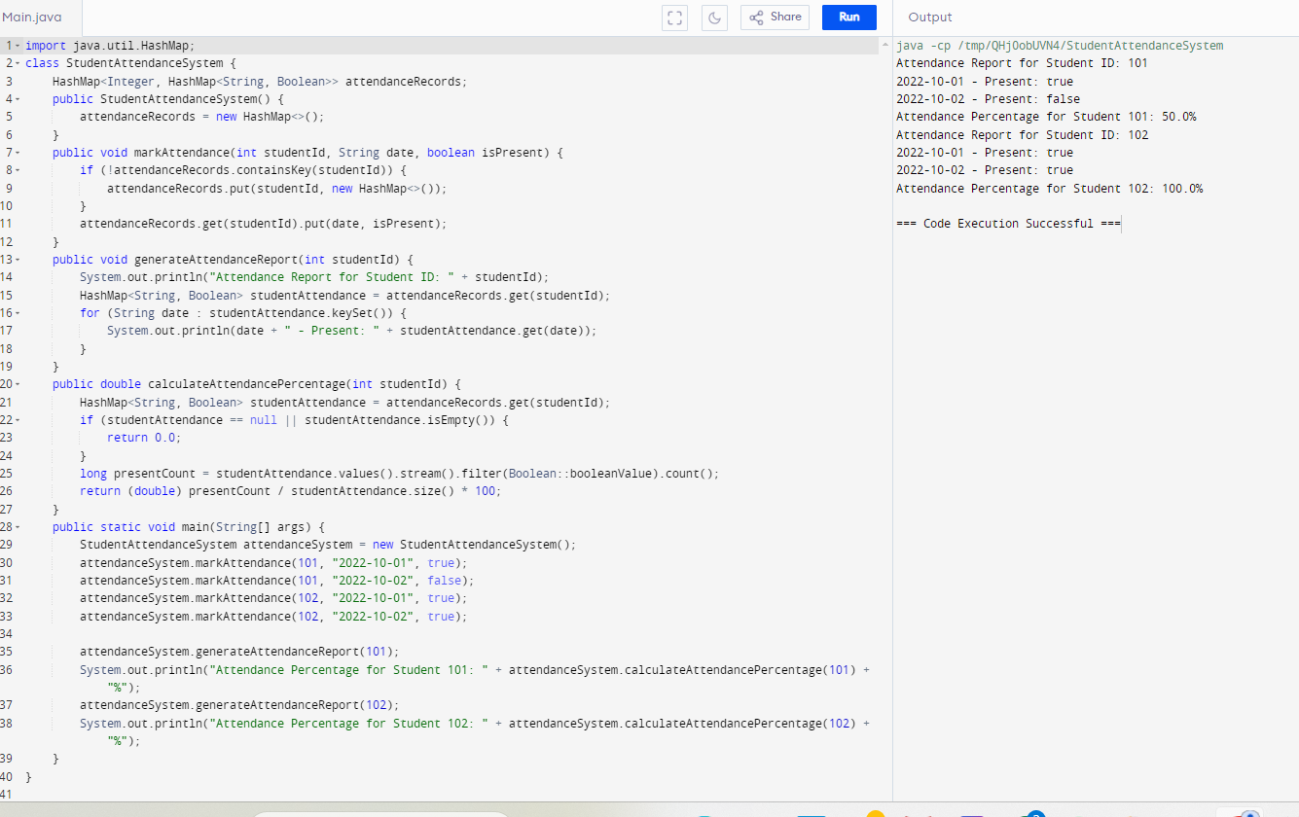

**2**. public class WeatherForecastApp {

public String getCurrentWeather(String location) {

return "Current weather for " + location;

}

public String getWeeklyForecast(String location) {

return "Weekly forecast for " + location;

}

public void displayWeatherDetails(String location) {

System.out.println("Weather details for " + location);

}

public static void main(String[] args) {

WeatherForecastApp app = new WeatherForecastApp();

String location = "New York";

String currentWeather = app.getCurrentWeather(location);

System.out.println(currentWeather);

String weeklyForecast = app.getWeeklyForecast(location);

System.out.println(weeklyForecast);

app.displayWeatherDetails(location);

}

}

